<<Your Project Name>>
<<Your Name and email>>
<<Company Name>>
<<Project Logo>>

<<Cover Page>>
<<This cover page should also go on the outside of your nicely bound project proposal>>
Copyrights and Legal Notice

<< On this page include any copyright information for your product, any registered trademarks you use within the document and any legal statements your company requires. Note: I am not allowed to sign non-disclosure agreements. The statement about the project proposal format at the bottom must remain on this page.>>

This project proposal format and the included documents are the property of Paula Hannan and may only be used with permission.
Signatures

__________________________________________ Date:_____________________
<<Student Name here>>

___________________________________________ Date: _____________________
Paula Hannan, OIT

Change Log
<<You will log all changes made to the document after your final version in 334. >>

Date | Version | Who | What Changed
 |  | PAH

Copyrights and Legal Notice ii
Signatures iii
Change Log iii
1 Introduction 5
1.1 Objectives 5
1.1.1 Project Objective Statement 5
1.1.2 Project Is / Is Not 5
1.2 Major Features 6
2 Project Context 7
2.1 Customer Profiles 7
2.2 Assumptions and Dependencies 7
3 Requirements 8
4 Project Success 10
4.1 Success Measures 10
Measure 1 - 10
4.2 Professional Development Considerations 10
5 Change Management 10
5.1 Flexibility Matrix 10
5.2 Assumptions and Constrains 11
5.3 Communication Plan 11
6 Risk Management 11
7 Customer Responsibilities 13
8 Technical Environment & Summer Actions 14
8.1 Technical Environment 14
8.2 Additional Summer Actions 15
9 Appendix A – Glossary 15

Introduction
<<In the introduction, you want to get the reader excited about this project. Why are you doing it? What is the business opportunity? What problem are you solving? What is the history of this problem or market? The introduction should also serve as an executive summary. If an executive can only read this section what do you want her to remember about your project? The entire introduction (All of section 1) should take between ¾ and 1 page.>>

Objectives

Project Objective Statement
<<In this section, provide the Project or Product objective statement. The objective statement summarizes what (scope) by when (schedule) with how much (cost). The objective statement should be 25 words or less in common English. The classic objective statement was John Kennedy’s:

First, I believe that this nation should commit itself to achieving the goal, before this decade is out, of landing a man on the Moon and returning him safely to the Earth

Notice that he says what must be accomplished by when. In the speech, he also talks about how much.>>

Project Is / Is Not
<<In this section, clarify the project by stating what the project is, and what it is not. Remember this is an executive summary>>

Is | Is Not

Major Features
<<In this section, summarize the major features or system components. Number your features from 1-5 so that you can trace your detailed design back to the major features. (And therefore, once I approve your proposal you cannot renumber the features.)

At this point, you are still at the 20,000 foot level. Therefore, you may have at most five major features. You may end up using information from your Customer Profiles Worksheet to complete this section. What would your customer want to see in a product of this type? >>

Project Context

Customer Profiles
<< In this section, you will summarize in paragraph form the information you uncovered when completing the Customer profile worksheet. Describe your customers and why they will like your product. >>

Assumptions and Dependencies
<<In this section, you list all the assumptions you made while creating the project proposal. Also, list any major dependencies required for the success of your project. >>

Requirements
<< In this section you will step down one level from the major features and list the higher-level project requirements. Note that we are NOT doing detailed requirements yet. Most of your requirements should map to a Major feature. (If they do not you may need to rethink your major features. Areas you should consider when developing requirements are:
- Functionality
- Usability
- Reliability
- Performance
- Supportability
- Interfaces
- Data
- Security/Safety
- Constraints – Are there any limitations on your program because of the desktop used? The network?
- Hardware or Software Platform Requirements
- Documentation and On-Line Help
- Training and Help Desk Support

ALL requirements must be measurable. For example:

“Decent Performance” is not a measurable requirement.
“Screen refreshes within 2 seconds” is measurable.

Requirements have unique fixed (unchanging) numbers. You must use the following numbering scheme:

0.# – Any requirement that is not tied to a feature. For example, performance requirements are not tied to a particular feature.
F#.# - All feature based requirements will use the feature number a period (.) and then a requirement number. For example if feature 1 has 5 requirements they would be 1.1, 1.2,1.3,1.4 and 1.5

You must use the enclosed spreadsheet to list your requirements

Note: This spreadsheet has an additional column, “use case” which you will fill in 412. >>

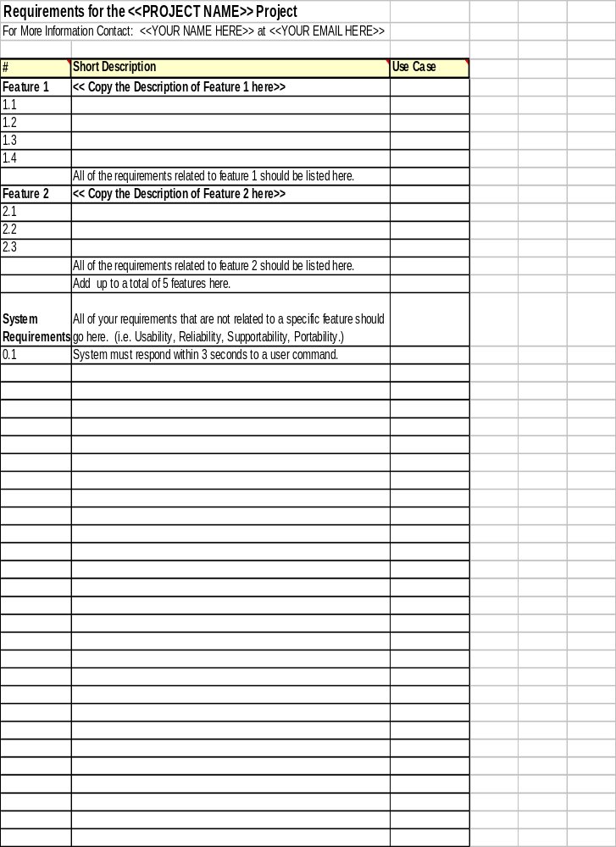

Project Success

Success Measures
<<List how to measure success for this project. Hint: Look at your most important customer and copy their success factor into your project metrics. You should provide a verbal description of the success measure and then a way to measure the success factor. You should have no more than three success measures. They should be easy to understand and easy to measure.

For example: You are developing a new order entry program. One of the major drivers of the project is the error rate in the existing system. So the success is measured by number of orders with errors.>>

The success of the project will be measured by:

Measure 1 -
Measure:

Professional Development Considerations
<<In this section you list how this project will further the professional development goals of your team members. (In this case, you.)>>

Name:
Goal 1 –
Goal 2 –

Change Management
<<In this section, you will describe what happens when things change in the middle of a project. Every project hits a point that requires tradeoffs. Smart project managers discuss these tradeoffs with the stakeholders at the time of the project proposal. In section 5.1 and 5.2, you will describe these tradeoffs and the assumptions and constraints around the tradeoffs.)>>

Flexibility Matrix
<<The flexibility Matrix clarifies assumptions about the dimensions of the project. When push comes to shove can you move the schedule (In this case probably not), change the scope (by lowering the Measures of Success (MOS), add more resources (sorry… not in this case)? >>

 | Most Flexible | Moderately Flexible | Least Flexible
Schedule
Resources
MOS | <<Replace this line with a table entry for your most important measures of success>>
Risk Level

Assumptions and Constrains

 | Constraint
Schedule | Project must be completed within schedule of 412, 422 and 432 Classes
Resources
MOS
Risk Level

Communication Plan
<<In this section, you will describe (At a high level) whom you will communicate with when changes occur in your project. >>

C (Consult) | A (Approve) | I (Inform) | R (Responsible) | O (Omit)

Risk Management
<<In this section, you will create your initial top 10-risk list. Normally each risk would have a separate owner, in this case its all you.

See Chapter 5 Risk Management and Best practice 41 Top-10 Risks lists in Rapid Development

Risk ID – A number to identify the risk. This ID number never changes.
Impact – If this challenge were to occur, how big of an impact would it have on your project? Rate the impact from 1 (least) to 10 (most).
Likelihood – How likely is this to happen? Rate the likelihood from 1 (least) to 10 (most).
Priority – Impact * Likelihood.

Sort your table by priority and list at most 10 risks.
>>

<< After you have listed and sorted your risks, you will create mitigation plans for them. Mitigation Plans include what you intend to do to prevent the risk from happening AND what you will do if it happens. In this project, you are the owner for all risks. Preventive actions are what you will do to prevent the bad thing (risk) from happening. (They may end up as tasks in the project plan in 412.) Contingent Actions are what you will do if the risk occurs. The trigger is the evidence that the risk has occurred.

Be sure to note any assumptions you are making in assessing this risk
>>

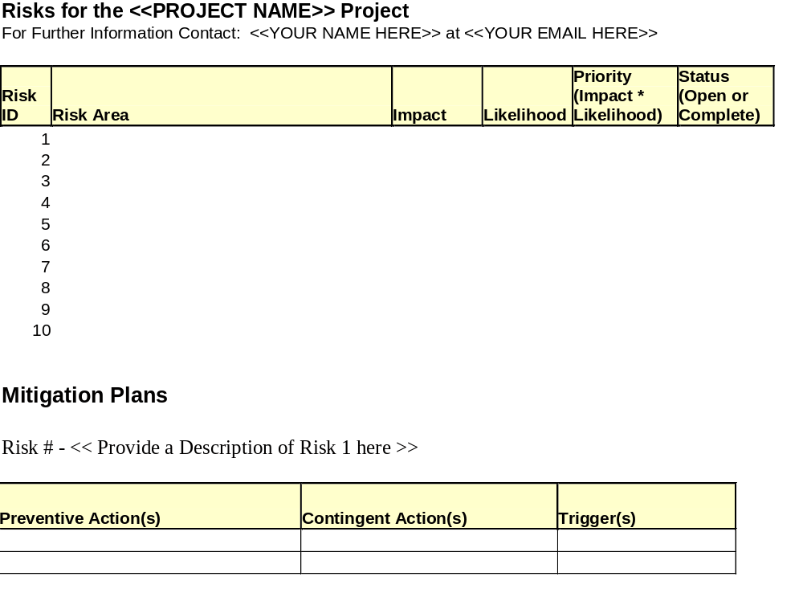

Customer Responsibilities
<<In this section, you list your agreements with your customer. What type system is required? Will the end user do beta testing for you? >>

Technical Environment & Summer Actions

Technical Environment
<< In this section, you describe your technical environment. You should only include this type of section if your audience is a technical one. In this case, I am technical, so you will include it. Here is a description of what to put in each column

Technical Area – In this column describe the different high-level tools you will need to complete your project. Leave the ones that I have included and add any additional ones you need.

Technical Tool Used - List the technology you plan to use. For example under "Programming Language(s)" you might have Java and Flash. Use N/A for technologies that do not apply to your application.

Where You Learned the Technology – In this column describe where you learned or where you plan to learn this technology. A big chunk of the technical work will occur this winter during 422, so you should have the bulk of your learning finished BEFORE winter term. Possible answers are:

- I took a class or I am taking a class this term. For your core technologies, I recommend that this class have been at least a 200 level class, for which you earned a B or better. If you have a weakness (For example you received a C in the corresponding class, or you feel like the class was too easy then you should plan on supplementing your knowledge with further research.)
- I am scheduled for a class summer term or I am schedule for a class fall term.
- I plan to read books during the summer on this topic.

Note: All projects will have a new technical area. Your new technical area is a risk and should be included in your Top-10 risk list. (Yes this means a slight amount of duplication.)

Summer Action – In this section put a check or asterix if you plan to do this learning during the summer.
>>

Technical Area | Technical Tool Used |  | Where You Learned the Technology |  | Summer Action?
Programming Language(s) | (Note that VB is not allowed as a programming language.)
Database | (Describe both the type of database and the tool you plan to use. Please note that MS-Access is not allowed. My SQL is an acceptable alternative.)
Middle Tier | (Note: All database centric applications must have a middle tier.)
Client Tier / User Interface
Networking | (Use N/A if you aren’t doing a Networking centric project.)
Gaming Graphics | (Use N/A if you aren’t doing a gaming project.)
Add any other technical components that are important to your project. | (For example:  PDA programming  Artificial Intelligence)

Additional Summer Actions
<<In this section, you will list any additional the action items for research you want to complete over the summer. >>

Appendix A – Glossary
<<Define any terms or TLA’s (Three Letter Acronyms) required to understand this project proposal. >>

From the JFK Library, “Special Message to the Congress on Urgent National Needs” President John F. Kennedy Delivered in person before a joint session of Congress, May 25, 1961 http://www.cs.umb.edu/jfklibrary/j052561.htm viewed 26 March 2002, Page created June 30, 1996, last updated: July 01, 2001.

